Trent Instruments Ltd - Coronavirus ( COVID-19) Statement
We continue to closely monitor developments with respect to the Coronavirus (COVID-19). In order to react to all eventualities we have nominated a senior member of staff to determine the appropriate measures which should be taken during this event. This person will help guide our actions in responding to a potential global outbreak including measures to reduce spread of the illness and maintaining business continuity including IT, procurement, manufacturing and supply chain functions. Questions……….
- What products are at risk?
Our products and assemblies contain parts supplied from the global market however and significantly the majority of our parts & assemblies are supplied from within the UK or from countries who have not had major outbreaks of the virus. We are working to track and trace of all shipments in transit to provide customers with updated estimated arrival times.
- Do you have any impact from your suppliers to produce materials?
Our procurement team has been actively engaged with our key part suppliers to understand any impact. Inventories & stock levels were built up prior to the end of 2019 and at this stage we do not foresee any shortage of key parts. We are working closely to ensure our suppliers can meet our needs to keep our manufacturing processes running.
- What impacts do you expect as a result of the rapid spread of the virus now being seen in Italy and other areas of the world?
We do not see any impact to our business or shipments at this time. We will continue to monitor the situation daily and will stay closely aligned with our customers in these areas.
- Are Trent instruments shipments from areas impacted by COVID-19 safe to receive at our facilities? Have they been fumigated, or other protective measures been implemented to contain the spread of the virus?
No guidance has been given by the World Health Organisation that fumigation or any other pro-active measures need to be taken in the handling and shipment of materials at this time.
- When can customers expect to know more about any potential impacts?
Our commercial team is very engaged with customers and are working to identify any potential impacts as we work through this together. Our sales teams are working with customers daily to assess the situation and potential slowdown in shipping and delivery.
- What restrictions has Trent Instruments implemented to keep its employees safe and healthy?
Trent Instruments continues to diligently monitor the evolving situation daily and is taking steps to ensure the safety and wellness of our employees. This includes reviewing travel plans (both internationally and domestically), reviewing business continuity plans, prudently evaluating the need and attendance at group gatherings and working to implement visitor guidelines for those coming to our location. Trent Instruments has also provided leaflets of NHS recommended hand cleaning regimes.
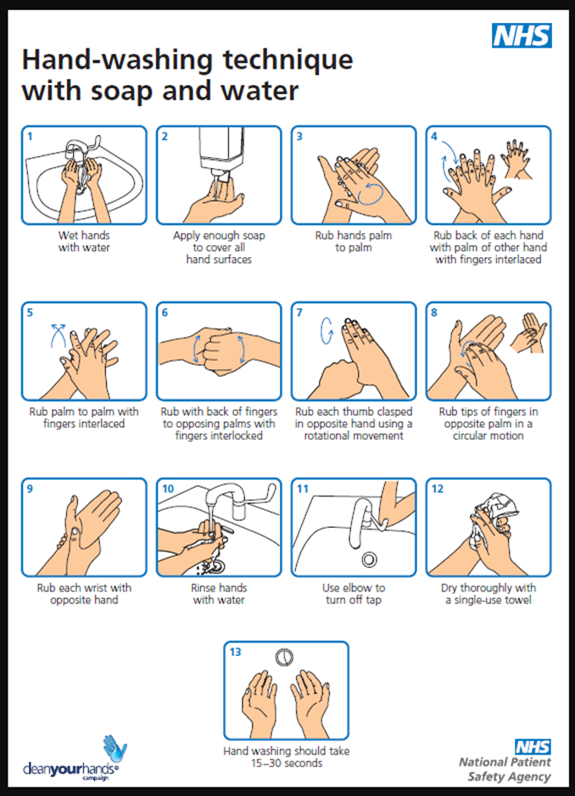
- What is your plan if several of your employees at our site are ill and cannot work?
Key team member and all the directors have mobile IT devices, i.e. laptops-smartphones which can remotely access the company IT systems. Potential staggered working hours so to reduce the numbers of team members on site at any one time has been considered.
Mark Buckley Date
Director

